Affordable Learning Georgia Textbook Transformation Grants
Final Report
Date: 12/23/16
Grant Number: 174
Institution Name(s): The University of Georgia
Team Members: Deanna L. Cozart – Coordinator of Open Education Resources, Center for Teaching and Learning, The University of Georgia. dcozart@uga.edu
DeLoris Wenzel Hesse – Associate Professor, Department of Cellular Biology, The University of Georgia. hesse@uga.edu
Brett G. Szymik – Assistant Professor, Department of Cell Biology and Anatomy, Georgia Regents University/The University of Georgia partnership. szymik@uga.edu
Rob Nichols – Lecturer, Department of Cellular Biology. The University of Georgia. Rob10367@uga.edu
Project Lead: DeLoris Hesse
Course Name(s) and Course Numbers: Anatomy and Physiology I and II Labs – CBIO 2200L & CBIO 2210L
Semester Project Began: Spring 2016
Semester(s) of Implementation: Fall 2016
Average Number of Students Per Course Section: CBIO2200/L = 891 students per year
CBIO2210/L = 712
Number of Course Sections Affected by Implementation: All lab sections
Total Number of Students Affected by Implementation: 1,603

1. Narrative
We began the transformation project having already adopted the Open Stax Anatomy & Physiology textbook for our lectures. During the 3 semesters prior to the pilot semester, we had been phasing in the textbook by first listing it as an alternate textbook in the spring and summer semesters of 2015, then as the required text in the fall semester of 2015. It was in the fall of 2015 when we first sat down to plan the transformation of our lab materials into an open source A&P lab manual built on the Open Stax text and hosted on the Open Stax CNX. Ideally, this would allow students to link to the lab modules, but also make the materials available to anyone wishing to use and modify them to fit their needs.
Our team started with existing materials that had been developed by some of the previous instructors and lead-TAs. These materials were in the form of PowerPoint slide sets that consisted primarily of figures from our previous textbooks, bullet-point lists of structures to identify, and some description of processes where appropriate (e.g., cardiac cycle, how to take blood pressure, etc.). We converted these existing documents into a word processor format, added the appropriate student outcomes (learning objectives), and began the process of writing additional content, linking it to specific sections and figures in the Open Stax textbook. The idea was that, rather than writing large amounts of content that had already been written in the textbook, we refer students directly to a section or figure in the text that they should read, study, and reference when preparing for the lab and the practicals. The only original material in the lab manual would be any procedures and objectives that are unique to a given lab.
This was one point at which we experienced one of our early challenges with the project. The Open Stax text is available in 4 different formats, only two of which have consistent page numbers, namely the hardcopy and the PDF version. There is an iBooks version available only for Apple products, but the pagination of this version is not consistent with the hardcopy/PDF. Further, the web-based version does not have page numbers at all. Though we have not done a formal survey of Open Stax usage in our classes, informal polls indicate most students use the web-based version in both of our courses. Additionally, in our design, the hyperlinks in our lab manual would link the reader to this web-based version of the Open Stax text. This was primarily an unexpected challenge for the transformation team, particularly between those of us writing the materials (the instructors of record for the two A&P courses), and the members of the team who were helping us create the links in the documents and publish the materials to CNX. Initially, to work around this, we would type the heading into our documents, but many of the headings in the text are quite long. To solve this problem, we created an indexing system in the text for chapter numbers, major headings, minor headings, and had to be sure that we were referring to the same figures in our documents (figures are not numbered consistently across all versions). So, we would have a document that looks like the sample below. Section headings are followed by textbook sections and figures in red with brackets, and relevant points and themes for the students listed below. The team members working on the CNX upload for us replaced the red text with a hyperlink that takes the students directly to the referenced section and/or figure in the web-based version of the Open Stax textbook. Though it seems like a simple solution, it greatly streamlined our workflow during the spring of 2016 as we prepared to pilot the lab manual in the summer semester.
The transformative impacts on instruction have centered around the unique opportunity to carefully reevaluate our curriculum, combing through every learning outcome across a two-semester sequence, to find overlaps and gaps in content. This has turned out to be an ongoing process that this transformation project has inspired. At the University of Georgia, we aspire to offer a world-class lab experience and curriculum for our students, and that means we are always looking for ways to improve both.
2. Quotes
“I prefer hard copy, but I am willing to use online if it means saving a couple hundred dollars!”
“I prefer having a hard copy of the text, but having it online didn’t make it less effective. I do like how it’s free and everyone is able to access it. Lab manuals are very expensive and most of the time all you use it for is to read the procedure. It is equally as effective to just post it online.”
“Having a free digital lab manual made my life as a college student much easier. I didn’t have to fight the crowds at the bookstore or wait for a book to come back in stock if sold out. I really like having an electronic lab manual because it is both eco-friendly and easily accessed.”
3. Quantitative and Qualitative Measures
3a. Overall Measurements
Student Opinion of Materials
Was the overall student opinion about the materials used in the course positive, neutral, or negative?
Total number of students affected in this project: 1,603 over the 2016-2017 school year
- Positive: 30.31% (137 students) of 455 number of respondents
- Neutral: 56.86% (257 students) of 455 number of respondents
- Negative: 12.83 % (58 students) of 455 number of respondents

Student Learning Outcomes and Grades
Was the overall comparative impact on student performance in terms of learning outcomes and grades in the semester(s) of implementation over previous semesters positive, neutral, or negative?
Student outcomes should be described in detail in Section 3b.

Choose One: (Unknown at this time – grades will be analyzed once available – see narrative below.)
- ___ Positive: Higher performance outcomes measured over previous semester(s)
- ___ Neutral: Same performance outcomes over previous semester(s)
- ___ Negative: Lower performance outcomes over previous semester(s)
Student Drop/Fail/Withdraw (DFW) Rates
Was the overall comparative impact on Drop/Fail/Withdraw (DFW) rates in the semester(s) of implementation over previous semesters positive, neutral, or negative?
Drop/Fail/Withdraw Rate: (Unknown at this time – see narrative below).
_______% of students, out of a total _______ students affected, dropped/failed/withdrew from the course in the final semester of implementation.
Choose One:
- ___ Positive: This is a lower percentage of students with D/F/W than previous semester(s)
- ___ Neutral: This is the same percentage of students with D/F/W than previous semester(s)
- ___ Negative: This is a higher percentage of students with D/F/W than previous semester(s)
3b. Narrative
This project was specifically unique in that it supported the creation of an open-source lab manual for exclusive use with the labs for Anatomy and Physiology I and II. The regular A&P lecture courses have been using the OpenStax A&P book for a little over one year; however, prior to this project, students were required to purchase a $162.00 lab manual to accompany the OpenStax text.
Pilot Study – Summer 2016
The lab manual was piloted in Summer 2016 with A&P students, where they were asked to complete a pre- and post-survey about their impressions of open and online learning materials. There were 72 students enrolled in the CBIO 2200 lab and 65 students enrolled in the CBIO 2210 lab. Student participation rates in both surveys were:
- Initial survey: second week of semester (2200 N = 58; 2210 N = 59)
- Secondary survey: last week of semester (2200 N = 54; 2210 N = 51)
Some of the more interesting results from the pilot the number of students who initially preferred a hard copy of the text, but were more open to an online option after utilizing the open materials during the course.
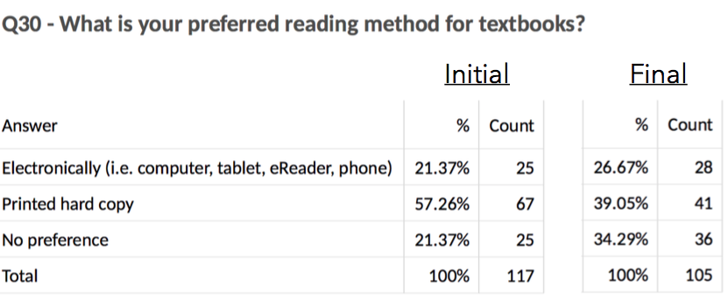
There was also a change in the number of students who believed online materials were of better quality than a traditional text. While not a statistically significant difference, it is certainly of practical significance that students had more favorable impressions of online learning materials after experience using them.
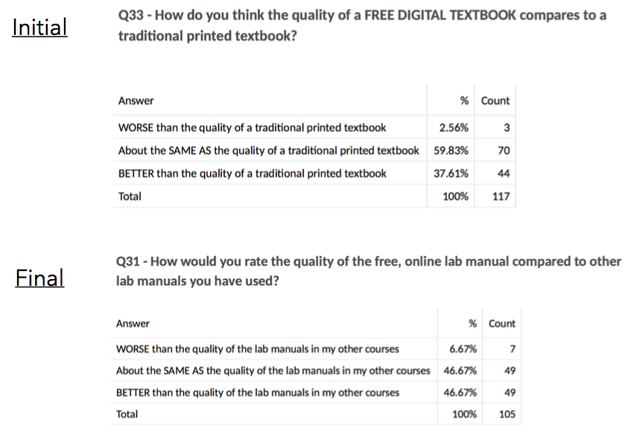
Students were also more willing to consider enrolling in a future course that utilized online learning materials after having used them in the lab over the summer.
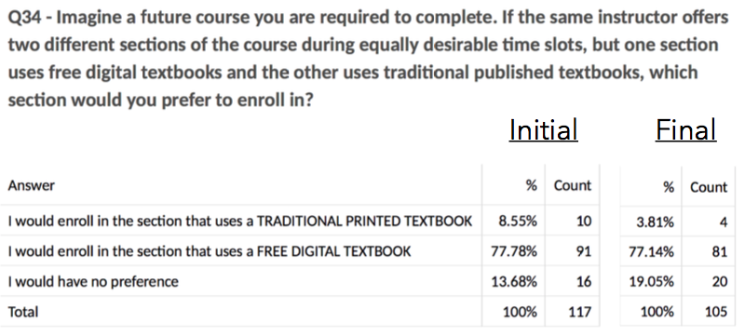
Implementation – Fall 2016
Pre- and post-surveys were also utilized with Fall 2016 students. These results are currently being analyzed, however, preliminary results indicate similar student views to the pilot in Summer 2016.
Grade and withdrawal/failure data is significantly more challenging to compile than the student survey. Because the lab is a co-requisite with the Anatomy and Physiology lecture (CBIO 2200 and CBIO 2210), students may not withdraw from the lab independent from the lecture. Additionally, students who withdraw from the lecture are automatically withdrawn from the lab. Thus, we can provide withdrawal data from the lecture courses, but not for the labs independently. We have requested the overall course withdrawal data from UGA, but have not received it now.
Grade data also offers a challenge; students receive a grade for the lab performance, however, it is not an official course grade, but rather a component of their overall lecture grade that is officially reported to UGA. We are working with individual lab instructors to compile the grade data for that portion of the class, though the historical data will be more challenging to ascertain, as it is not centrally reported. Anecdotal evidence suggests students performed at similar levels with the open lab manual as with the traditionally published one in the past.

4. Sustainability Plan
The project team will promote the use of these OER course materials (lab and lecture texts) as required texts for our Anatomy and Physiology courses for the foreseeable future. We plan to continually update and edit these course materials as necessary.
5. Future Plans
This project has served to increase the project team’s awareness of available OERs and their use in large enrollment courses. One project member (Hesse) discovered freely-available textbooks for use in her Medical Gross Anatomy and Medical Embryology courses taught in the AU/UGA Medical Partnership, and thus has been able to reduce textbook costs to these medical students.
The data collected as part of this grant have already been presented at the 13th Annual Open Education Conference ((http://sched.co/7lo3) and have been submitted to the 2017 University System of Georgia Teaching and Learning Conference. The final results of this project will be submitted to a peer-reviewed journal by June 2017.
In addition to presentations and papers, this project has inspired the team to produce an open access manual for laboratory instructors. We are currently discussing this project with OpenStax.
6. Description of Photograph
Rob Nichols of the project team with his CBIO students who utilized the open lab manual.

