**Affordable Learning Georgia  
Open Mathematics in Action**

**Final Report**

**Date: May 14, 2017**

**Grant Number: 7217005**

**Institution Name: East Georgia State College**

**Participant: Christine Xie**

**Course Name(s) and Course Number(s): College Algebra - Math1111**

**Average Number of Students Per Course Section: 21**

**Number of Course Sections Affected by Implementation: 2**

**Total Number of Students Affected by Implementation: 41**

**1. Narrative**

A. Describe the key outcomes, whether positive, negative, or interesting, of your project. Include:

* Summary of your transformation experience, including challenges and accomplishments

1. Save $93 in average per student who. Potentially, can save $150k total a year if all students use OER (Open Stax textbook + WebAssign).
2. Have same learning outcomes compared with much more expensive textbook (Pearson MyMathLab) in according assessments (success rate and gain rate).
3. More than 90% of students have textbook with homework management system ready in the first week of class, which allows students to do homework and study the course material the same pace as lecture instead of wait for financial aids. Compared with the courses using Pearson MyMathlab, only about 40% of students purchased the book bundle in the first week of class, which make a lot of students get behind of class which result in fail for the course at the end.
4. The only challenge using OER is the PPT presentations provided by Open Stax not good enough to teach the course. The instructor have to spend much more time to prepare new PPT for the course.

* Transformative impacts on your instruction

1) A lot of communication and interaction with students via WebAssign to answer questions, grand extension request etc.

2) More use of textbook in class since textbook is in the PDF form and easy to access for both instructor and students.

* Transformative impacts on your students and their performance

1) Students can access textbook in PDF file for free. Textbook can be easily assessed by specific page, or topic, or section, or chapter. More use of textbook can engage students more in learning.

2) Cheap homework management system WebAssign is user friendly and easy to register/assess, which allows students engage in class earlier in the semester.

B. Describe lessons learned, including any things you would do differently next time.

1. The college algebra support class must be linked with college algebra class.
2. Make more videos available to students so that they can watch and/or re-watch them after class when having difficulty to do homework problems.

**2. Quotes**

* Provide three quotes from students evaluating their experience with the no-cost learning materials.

1) “So nice to use cheap textbook. I can save some money.”

2) “I don’t have to wait for the financial aid to pay for this textbook.”

3) “Easy to register for WebAssign.”

4) “Not much example/instruction when I have difficulty doing homework.”

**3. Quantitative and Qualitative Measures**

**3a. Overall Measurements**

**Student Opinion of Materials**

**Was the overall student opinion about the materials used in the course positive, neutral, or negative?**

Total number of students affected in this project: __41______

* Positive: _ 37.5_____ % of __24_____ number of respondents
* Neutral: __45.8_____ % of __24______ number of respondents
* Negative: _16.7_____ % of __24______ number of respondents

**Student Learning Outcomes and Grades**

**Was the overall comparative impact on student performance in terms of learning outcomes and grades in the semester(s) of implementation over previous semesters positive, neutral, or negative?**

*Student outcomes should be described in detail in Section 3b.*

Choose One:

* ___ Positive: Higher performance outcomes measured over previous semester(s)
* _X_ Neutral: Same performance outcomes over previous semester(s)
* ___ Negative: Lower performance outcomes over previous semester(s)

**Student Drop/Fail/Withdraw (DFW) Rates**

**Was the overall comparative impact on Drop/Fail/Withdraw (DFW) rates in the semester(s) of implementation over previous semesters positive, neutral, or negative?**

**Drop/Fail/Withdraw Rate:**

__48.8____% of students, out of a total _41____ students affected, dropped/failed/withdrew from the course in the final semester of implementation.

Choose One:

* ___ Positive: This is a lower percentage of students with D/F/W than previous semester(s)
* _X_ Neutral: This is the same percentage of students with D/F/W than previous semester(s)
* ___ Negative: This is a higher percentage of students with D/F/W than previous semester(s)

**3b. Narrative**

The assessment data provided below includes three quantitative measures and one qualitative measure. The quantitative measures are: gain rate, success rate and DFW rate; and the qualitative measure is the survey. For the quantitative measures, the comparison data for the course(s) not using OER (Pearson MyMathlab) is also provided. From data collected, I performed statistical analysis and conclude that there is NO difference between the courses use OER (OpenStax+WebAssign) and the courses use expensive textbook (Pearson MyMathLab) in terms of learning outcomes.

1. gain rate:



|  |  |  |  |  |  |
| --- | --- | --- | --- | --- | --- |
| **Sections**  **Fall 2016** | **# of**  **student** | **Pretest**  **Mean** | **Posttest**  **Mean** | **Gain Rate** | |
| **Pearson 1** | **37** | **33** | **53** | **60.61%** | **57.33%** |
| **Pearson 2** | **33** | **37** | **57** | **54.05%** |
| **WebAssign** | **22** | **32** | **53** | **65.63%** | |

Statistical Analysis For Fall2016:

A) effect size: a way of quantifying the size of the difference between two groups.

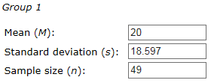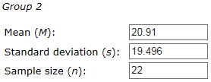

Success!

Cohen's *d* = (20.91 - 20) ⁄ 19.051803 = 0.047765.

Glass' *delta* = (20.91 - 20) ⁄ 18.597 = 0.048933.

Hedges' *g* = (20.91 - 20) ⁄ 18.875142 = 0.048212.

Because the size of the difference between two groups is only about 5%, we can conclude that there is NO difference between the two groups.

B) two sample T-Test: is used to determine if two population means are equal.



Where: µp is the mean of gain (posttest-pretest) of the course use Pearson MyMathLab, µw is the mean of gain (posttest-pretest) of the course use OER (OpenStax + WebAssign).

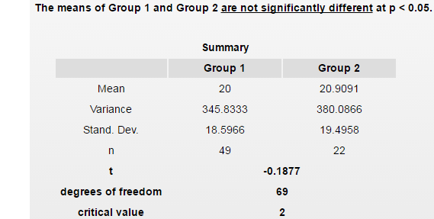

Critical Region: Reject the null hypothesis that the two means are equal if 

Result: |T|=|−0.1877| = 0.1877 < 1.995

Because the absolute value of T less than critical value, we fail to reject the null hypothesis and can conclude that there is NO difference between the two group means.

|  |  |  |  |  |
| --- | --- | --- | --- | --- |
| **Sections**  **Spring 2017** | **# of**  **student** | **Pretest**  **Mean** | **Posttest**  **Mean** | **Gain Rate** |
| **Pearson 1** | **14** | **34** | **54** | **58.82%** |
| **WebAssign** | **4** | **38** | **65** | **71.05%** |

Statistical Analysis For Spring2017:

A) effect size: a way of quantifying the size of the difference between two groups.

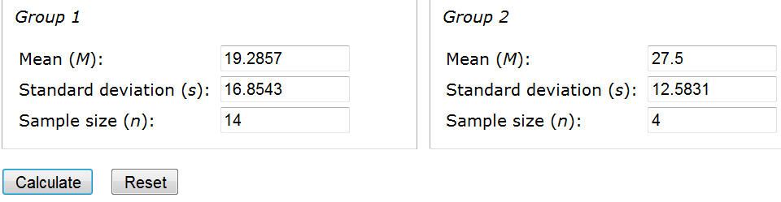

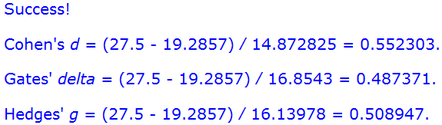

The size of the difference between two groups is about 50%. It’s hard to tell if the two group means are statistically different or not. Therefore, we have to run a two sample T-test to do more test.

B) Two sample T-Test: is used to determine if two population means are equal.



Where: µp is the mean of gain (posttest-pretest) of the course use Pearson MyMathLab, µw is the mean of gain (posttest-pretest) of the course use OER (OpenStax + WebAssign).

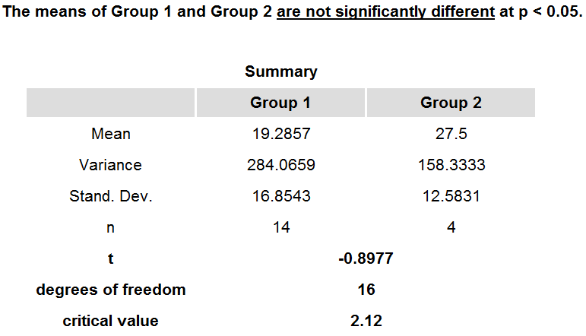

Critical Region: Reject the null hypothesis that the two means are equal if 

Result: |T|=|−0.8977| = 0.8977 < 2.12

Because the absolute value of T less than critical value, we fail to reject the null hypothesis and can conclude that there is NO difference between the two group means.

1. Success rate:



|  |  |  |  |
| --- | --- | --- | --- |
| **Fall2016** | **WebAssign** | **Pearson 1** | **Pearson 2** |
| Success Rate | 53.13% | 64.86% | 51.52% |
| Success Rate | 53.13% | 58.19% | |

The difference between two groups’ success rate for Fall2016 is about 5%.

|  |  |  |
| --- | --- | --- |
| **Spring2017** | **WebAssigne** | **Pearson** |
| Success Rate | 44.44% | 25.71% |

The difference between two groups’ success rate for Fall2016 is about 18%.

1. DFW (Drop, fail, withdraw) rate:



|  |  |  |  |
| --- | --- | --- | --- |
| **Fall2016** | **WebAssign** | **Pearson 1** | **Pearson 2** |
| DFW Rate | 40.63% | 35.14% | 48.48% |
| DFW Rate | 40.63% | 41.81% | |

The difference between two groups’ DFW rate for Fall2016 is almost the same.

|  |  |  |
| --- | --- | --- |
| **Spring2017** | **WebAssigne** | **Pearson** |
| DFW Rate | 55.56% | 65.71% |

The difference between two groups’ success rate for Spring2017 is about 10%.

1. Survey

Multiple choice survey question:

What is your overall opinion about the OER materials used in the course?

1) positive 2)neutral 3) negative

**Result: 24 responses received**

9 Positive responses, which is: 37.5% of total number of respondents

11 Neutral responses, which is 45.8% of total number of respondents

4 Negative responses, which is 16.7% of total number of respondents

For both Fall2016 and Spring2017 semesters, the College Algebra Support classes were not linked with College Algebra classes due to last minute emergencies. For that reason, I have to rearrange the order of materials of OpenStax to match with Pearson textbook. This might create some difficulty for students to read and/or use OpenStax textbook.

**4. Sustainability Plan**

If continue to use OER material, I would like to either make or find some videos of class examples so that students can watch them after class.

**5. Future Plans**

Use OER can reduce students’ financial burden and make students to get engaged in class earlier than expensive textbook options, which potentially increase students’ success rate. We should promote OER in University System of Georgia or in higher education setting in general.

I have present Mathematics in Action project in Teaching and Learning Conference in Athens, Georgia back to April of 2017.