Affordable Learning Georgia Textbook Transformation Grants
Final Report: ALGR2#82
Date: 7/25/2015
Grant Number: ALGR2#82
Institution Name(s): Dalton State College
Team Members (Name, Title, Department, Institutions if different, and email address for each):
Molly Zhou, Assistant Professor of Education, School of Education, Dalton State College, mzhou@daltonstate.edu
David Brown, Instruction and Technology Librarian, Derrell C. Roberts Library, Dalton State College, dobrown@daltonstate.edu
Project Lead: Molly Zhou, Assistant Professor of Education, School of Education, Dalton State College, mzhou@daltonstate.edu
Course Name(s) and Course Number(s): EDUC3214 Exploratory Activities in Physical Education, Art, and Music
Semester Project Began: Spring 2015
Semester of Implementation: Summer 2015
Average Number of Students Per Course Section: 30
Number of Course Sections Affected by Implementation: One section of the course offered in Summer 2015
Total Number of Students Affected by Implementation:
A total of 23 enrolled in summer section of the course. This course was approved in March 2015 to be offered in summer 2015 for the first time.
1. List of Resources Used in the Textbook Transformation

There are 5 sources that are used as primary readings for the course. These are:

Chapter One Source: Markey, D. (2014). The case for integrated arts in the classroom. Washington Parent Magazine. Retrieved from http://www.washingtonparent.com/articles/1305/arts-integration.php

Chapter Two Source: Sheinfeld, D. (2004). Arts integration in the classroom: Reflections on theory and application. Applied Research in Child Development Newsletter. Retrieved from http://www.erikson.edu/wp-content/uploads/arcd52004.pdf

Chapter Three Source: Brewer, C. (1995). Music and learning: Integrating music in the classroom. Johns Hopkins School of Education. Retrieved from ttp://education.jhu.edu/PD/newhorizons/strategies/topics/Arts%20in%20Education/brewer.htm

Chapter Four Source: Flory, A. (2008). Exploring the benefits of art in elementary education. California State University Honors Program Journal. Retrieved from https://www.csustan.edu/sites/default/files/honors/documents/journals/elements/Flory.pdf
Chapter Five Source: Moore, M. (2004). Using drama as an effective method for teaching elementary students. Eastern Michigan University Digital Commons. Retrieved from http://commons.emich.edu/cgi/viewcontent.cgi?article=1112&context=honors

A total of 163 other sources were also used as recommended/additional readings for the course. They are listed in APA style including websites, Galileo articles, Dalton state library books, journal articles, and tutorials. The learning materials can be accessed through the following URLs:
The LibGuide link for Educ3214: http://libguides.daltonstate.edu/educ3214
The digital repository link for educ3214: http://rrscholar.openrepository.com/rrscholar/pages/educ3214.html

2. Narrative
A. Describe the key outcomes, whether positive, negative, or interesting, of your project. Include:
- Summary of your transformation experience, including challenges and accomplishments
This experience has been a wonderful one and inspirational one working on this project. I learned so much about different art forms and sources that students could use to enrich their own teaching and students’ learning in the classroom. I enjoyed working with the team member from the library. I enjoyed searching and creating new learning materials for my students. I especially enjoyed seeing that students were engaged and were all participatory in the learning process and they mentioned this course was so fun, interesting, and they learned a lot in the course whishing all other courses were like this. My experience has been overall positive on this project. This the second funded ALG project on textbook transformation so we did not run into challenges during the learning materials creation stage or during the implementation stage. The class was well designed to have appropriate activities for each different learning unit on different art forms. The accomplishments of the project include the finished product: the learning materials, the corresponding PPT slides, zero cost on learning materials for students, increased students’ engagement in the learning process, complete satisfaction on the overall course from students, and excellent student evaluation 5 out of 5.
- Transformative impacts on your instruction
The newly created learning materials fit into my teaching style, teaching methods, course delivery methods, and the learning objectives of this course. I have enjoyed teaching this group of students. The learning materials make the course so interesting, practical, and so straightforward to teach what I want to teach.
From my teaching perspective, I had enjoyed developing the materials while learning so much about a variety of arts forms. I have enjoyed the flexibility and creativity that I was able to have before the project to put the learning activities together.
The learning materials development process and the content selection made me very comfortable to teaching the learning materials. I felt at ease when instructing the materials and assessing students’ learning progress due to the engagement in the learning materials selection and creation process. I felt I am empowered to do what I should have done years back. I enjoyed teaching the newly created learning materials to students with students’ need, levels, knowledge base, and participation, creativity, flexibility, and level of comfort level on technology in mind.
- Transformative impacts on your students and their performance
I could definitely see the difference on the dynamics in the classroom when implementing the learning materials. Students were so engaged in the learning process. They loved the learning materials. They also liked the idea and fact that course learning materials, instructional methods, teaching styles, course delivery, class assignments, and course activities all went together seamlessly. In addition, they loved the use of OER so that they did not have to pay for a costly textbook. On the Learning Materials Questionnaire, all of them marked that they liked the learning materials and some especially commented that they liked to see more or all of their classes were like that.
I thoroughly enjoyed seeing the magic change in my classroom during the implementation of the learning materials. Students came to class with smile, they inquired about their learning in class, they actively inquired about tests, and they creatively showcased their talents in using arts to enrich their teaching in the classroom. This is the type of learning environment that fosters true learning.
B. Describe lessons learned, including any things you would do differently next time.
Student loved to have PPT slides to be part of their learning materials. They liked the idea that PPT slides were brief, concise, and to the point to help them learn. They also pointed out that they would like to see more videos embedded in the slides. That aspect of improvement has already been made. Some students also mentioned they would like to see more examples of arts integration lesson plans. That aspect has been worked on. A total of four arts integration lesson plans have been added to the learning materials focusing on math, science, social studies, and language arts. Those newly added learning materials will be implemented in the fall 2015 section. Students like the fact they were able to have electronic access. Due to the content coverage and sources introduced, the length of the document was a little long for some students to scroll back and forth, which made it uneasy. Regarding that, the whole reading text has been broken into different shorter sections by chapter so that it will be easier for them to locate the chapter with more ease in D2L in the fall of 2015.
3. Quotes
Provide three quotes from students evaluating their experience with the no-cost learning materials.
- It was such a relief to not have to purchase a book for this course. The online text and materials were more appealing than a physical book. I used the online materials more than I ever would have on an actual physical book.
- I thought the textbook for the course was amazing. It did not have "fluff", got to the important points, and the additional resources were a great help!
- Even though the book was free, it was every helpful with my learning experience. Sometimes the books we have to buy are boring and not helpful or we do not use them at all.

4. Quantitative and Qualitative Measures
A total of 23 students enrolled in the summer section for the implementation of the project in summer 2015. No students dropped, failed, or withdrew from the course from beginning to the end of the course. All students scored within the A range at the end of the summer semester with a high of 100 and a low of 92 percent. The results on the proposed assessment measures including both quantitative and qualitative measures are summarized below from Table 1 to Table 6:
Based on the semester’s learning, students pre-post test results indicated significant learning gain in the course. As indicated in Table 1 an average of 7.65 point increase was observed from pre to post test, which is an average of 30.61% increase. The average score for the assessment on pre-test was 17.09 and 24.74 on the post test. All students showed positive increase.

Table 1.
Arts Integration Pre-Post Test Results
 | Pre | Post | Max | Min | Pre-Post
Max | 21.00 | 25.00
Min | 11.00 | 23.00
Mean | 17.09 | 24.74
Mean% | 68.35 | 98.96
Pre-Post DIF |  |  | 14.00 | 4.00
Pre-Post DIF% |  |  | 56.00 | 16.00
Pre-post DIF Mean |  |  |  |  | 7.65
Pre-post DIF Mean % |  |  |  |  | 30.61
Note: N=23

In terms of content elements on the assessment, data in Table 2 showed that students had tremendous gain in the content area with an average gain of 38.20% on focus, 52.20% gain on content coverage, and a gain of 50.60% in content reflection.
Table 2.
Means of Arts Integration Pre-post Test Results by Element
Element | Pre | Post | DIF | DIF%
Writing Mechanics | 4.91 | 5.00 | 0.09 | 1.80
Organization | 4.48 | 5.00 | 0.52 | 10.40
Content: Focus (music, art, and P.E. integration) | 3.09 | 5.00 | 1.91 | 38.20
Content: Coverage | 2.30 | 4.91 | 2.61 | 52.20
Content: Reflection | 2.30 | 4.83 | 2.53 | 50.60
Note: N=23

Themed Discussion was used to assess students’ learning as the semester moved along. The results were summarized in Table 3 below. Overall, students did well on the themed discussions and all themes were scored with an average 90% or more. However, close examination indicated that the minimum score for Art and P.E. Movement were lower than Music with a low score of 80% for Music and a low score of 60% for Art and P.E. Movement respectively.
Table 3.
D2L Themed Discussed Results
Theme | Max | Min | Mean
Music | 10.00 | 8.00 | 9.61
Art | 10.00 | 6.00 | 9.52
P.E. Movement | 10.00 | 6.00 | 9.30
Note: N=23

The Arts Integration Research Paper results were summarized in Table 4. There was a slight increase in class wide gain for 1.33 points. However, due to unequal number of students enrolled in the course in different semesters, it is hard to determine whether that increase is significant or not. A close examination also revealed that the low score in spring semester was a 0, which was a result of a student did not submit the assignment, but the low score for the summer section was 17. This means a difference in that more students enrolled in the summer section and all students completed the assignment. The indicated students involvement and participation in their learning in the course moved toward a positive direction.

Table 4.
Arts Integration Research Paper Results
Semester | Max | Min | Mean | N
Spring 2015 | 20.00 | 0.00 | 18.19 | 21
Summer 2015 | 20.00 | 17.00 | 19.52 | 23

The results of the Learning Materials satisfaction survey were summarized in Table 5. Overall, students indicated very positive feedback on the learning materials provided. The average items score was 4.89 with 5 items scored a perfect 5. On the survey, five students put stress marks on item 9 to express their desire for other classes to be like this one in which they did not have to purchase a textbook.
Table 5.
Results of Satisfaction Survey by Item
 | IT1 | IT2 | IT3 | IT4 | IT5 | IT6
Total | 115.00 | 115.00 | 103.00 | 114.00 | 106.00 | 111.00
Mean | 5.00 | 5.00 | 4.48 | 4.96 | 4.61 | 4.83
 | IT7 | IT8 | IT9 | IT10 | IT11 | IT12 | Grand
Total | 112.00 | 114.00 | 115.00 | 115.00 | 114.00 | 115.00 | 1349.00
Mean | 4.87 | 4.96 | 5.00 | 5.00 | 4.96 | 5.00 | 4.89
Note: N=23

From the same assessment instrument, open ended questions also gathered great positive feedback on the learning materials provided in the course. Students’ comments were tallied and themed and summarized in Table 6. Overall students were very pleased with the content provided in the learning materials. They positively remarked on the easy access and cost saving factor. They enjoyed learning using the learning materials, which had provided a lot of hands-on learning activities for them. They really enjoyed the fun and engaging activities in this course. They highly remarked their learning in the course was effective and useful. Some students also mentioned that if could be nice to have a paper copy available for them and more video and examples could be added to enrich their learning in the class.
Table 6.
Results of Open-ended Questions From the Satisfaction Survey on Learning Materials
Elements | Frequency
Content | 20
Access | 15
Cost | 11
Effective Usage for Learning | 10
Activities | 7
Paper Copy | 8
More Videos/Examples | 6

5. Sustainability Plan
The hard copies of the learning materials have been made available in the College library and the School of Education model classroom. Electronic access to the materials is made available through course LibGuide and Digital Repository. The learning materials have been shared with other colleagues who are interested in using the materials. I have been assigned to teach the course in the fall semester of 2015 and I will continue to use the learning materials for the course. I have made changes to the learning materials based on the feedback from the summer 2015 implementation and I will continue to dialogue with others who will be using the materials on possible changes or improvement on the learning materials.
6. Future Plans
I liked the fact that students welcomed this type of change in their education. My experience has been very positive. I am thinking about make more and more learning materials available through OER to students for other classes I am teaching and the ones I will be teaching in the future. Through this project, I am better at identifying OER sources and the process of getting permission to use copy righted materials for classes as well. I will continue to explore more opportunities that will support college recruitment, retention, and graduation efforts to realize USG’s Complete Georgia initiatives.
As a result of this project, I have presented a webinar nationally on arts integration with IGI global. I have also submitted a conference proposal for SRATE conference in October 2015, Jekyll Island, Georgia. I will be also presenting on OER during faculty assembly for fall 2015. I will be also presenting within USG system in October on OER in the fall as well.

7. Description of Photograph
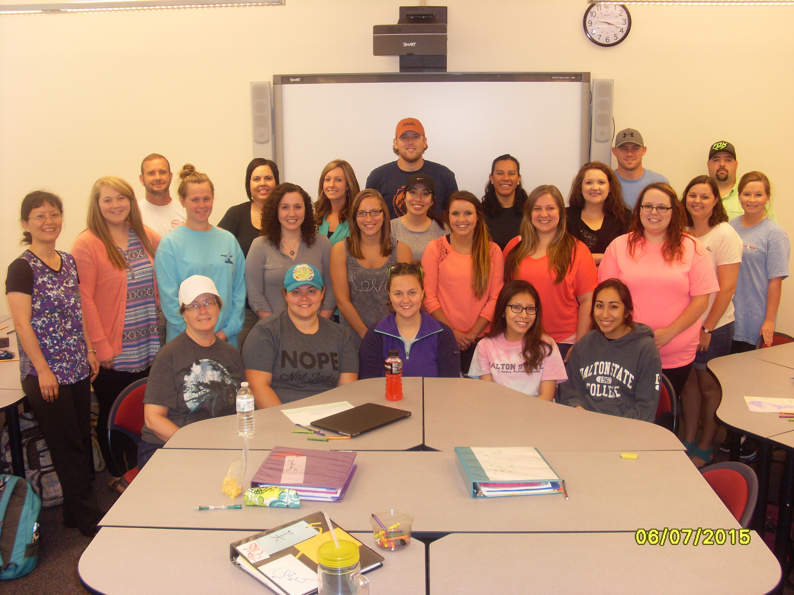
Back Row:
Dr. Molly Zhou, Sarah Douglas, Hannah Humphrey, James Chambers, Samantha Brown,
Katelyn Tallant, Ashlyn Benac, Ashley Wiggins, Liana Barrera, Derek Roberts, Kelby Holbrook, Maria Beckman, Mandy Owens, Shaylee Kissner, Kelby Holbrook, Angela Warren, Gabrielle Vasalinda, Bobby Chancey, Marci Weeks

Front Row:
Sandra Fairchild, Christina Pack, Tiffany Curtis, Brenda Hinojosa, Vanessa Pacheco

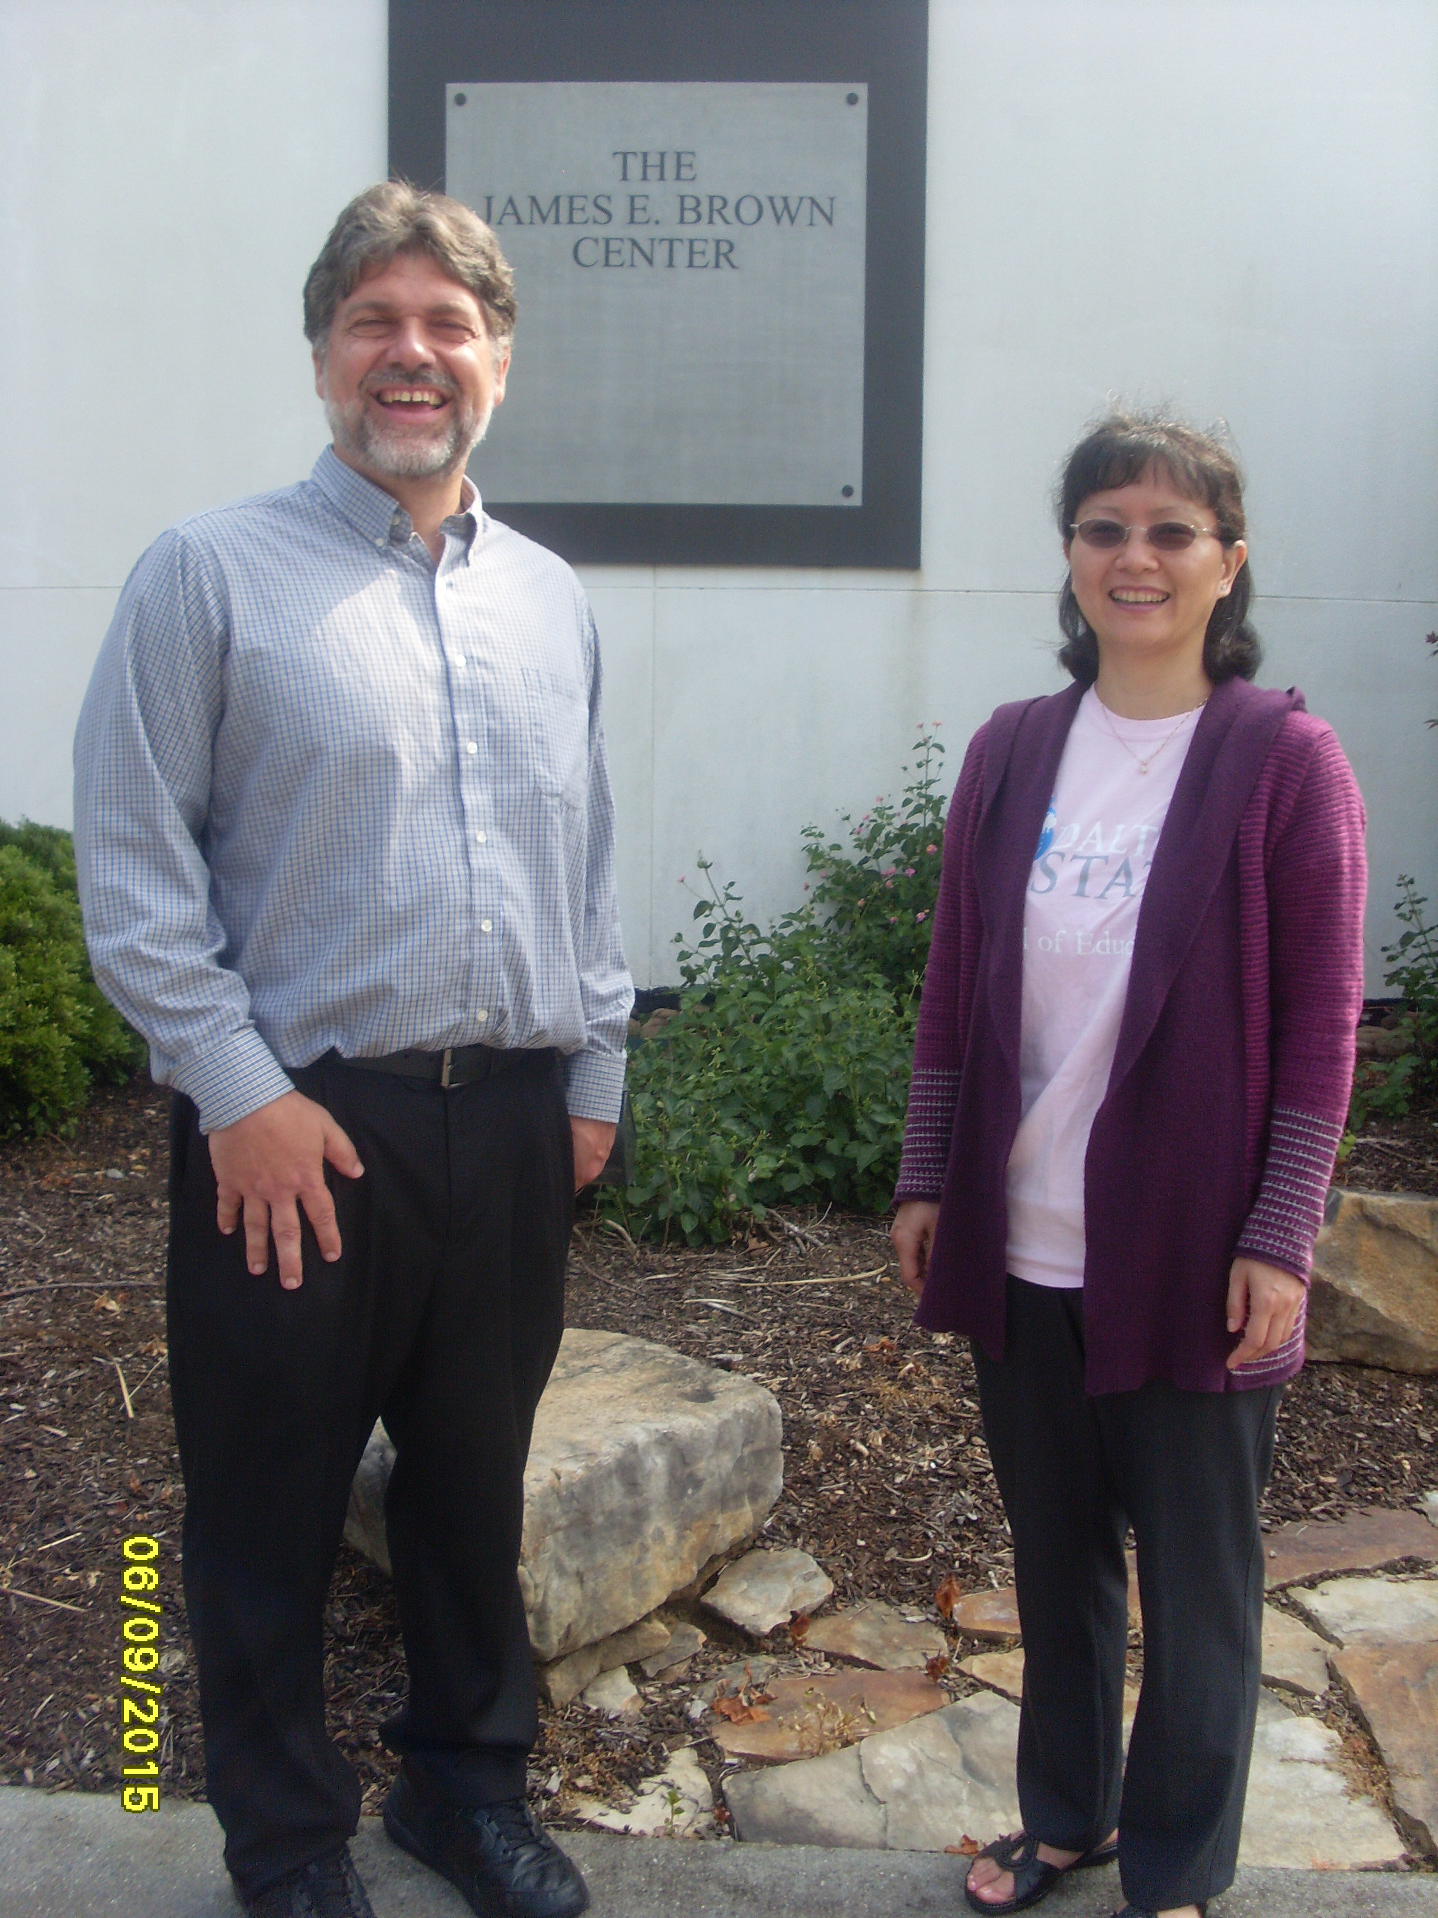
The second picture is the project team:
Left-David Brown: Instructional Technology Librarian, Team Member
Right-Dr. Molly Zhou, Assistant Professor of Education, Team Lead

